DevOps Model Defined

DevOps is the combination of cultural philosophies, practices, and tools that increases an organization’s ability to deliver applications and services at high velocity: evolving and improving products at a faster pace than organizations using traditional software development and infrastructure management processes. This speed enables organizations to better serve their customers and compete more effectively in the market.

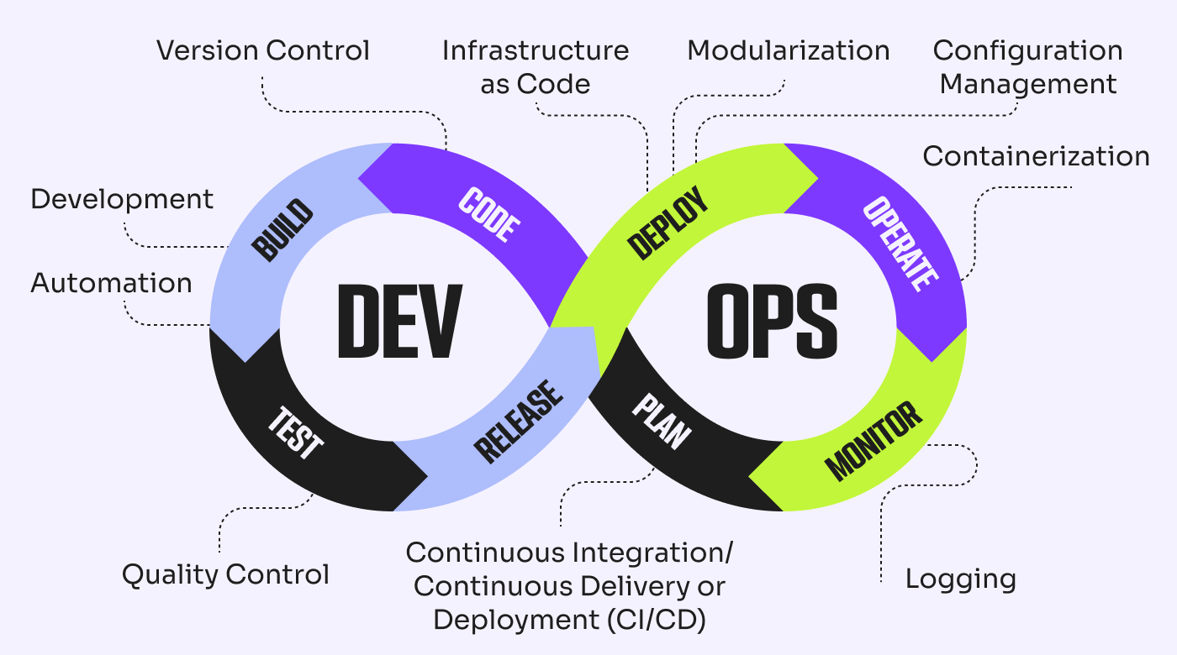

Benefits of DevOps

Speed

Rapid delivery

Reliability

Scale

Improved collaboration

Security

Top DevOps Challenges

1. Selecting the Right DevOps Metrics

2. Security in DevOps

3. Microservices Increasing Complexity

4. Change Is Huge

5. Choosing and Adopting the Right DevOps Tools

6. Lack of Cross-Functional Teams

7. Implementing the DevOps Center of Excellence

8. The Stringency of DevOps Governance

9. Managing Multiple Environments

10. Implementing Budgets